**Homework 2: Route Finding**

**Part I. Implementation (6%):**

* **Part 1:**

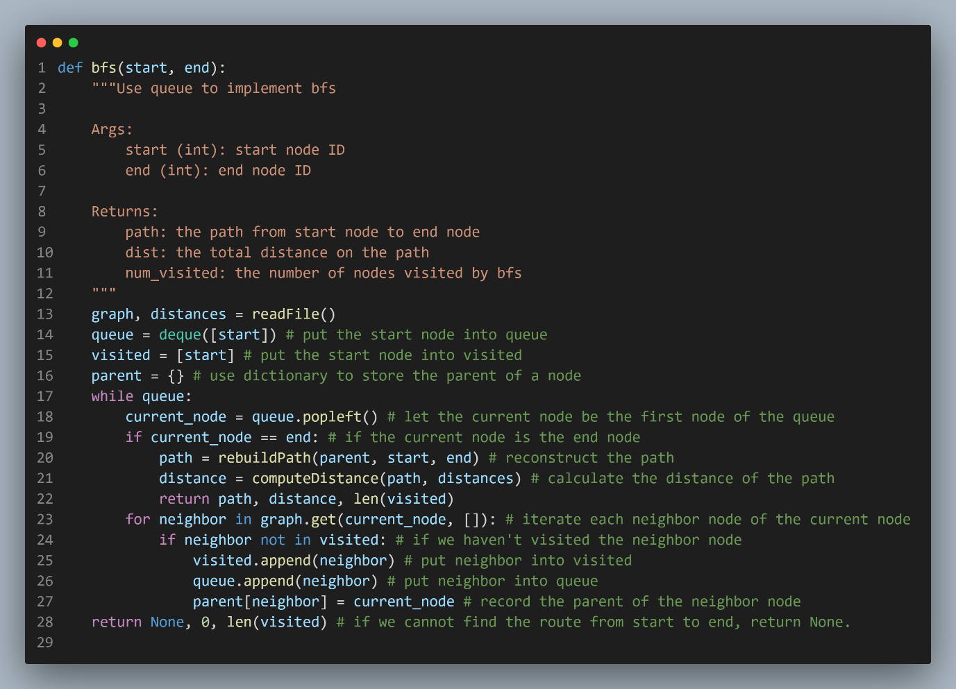

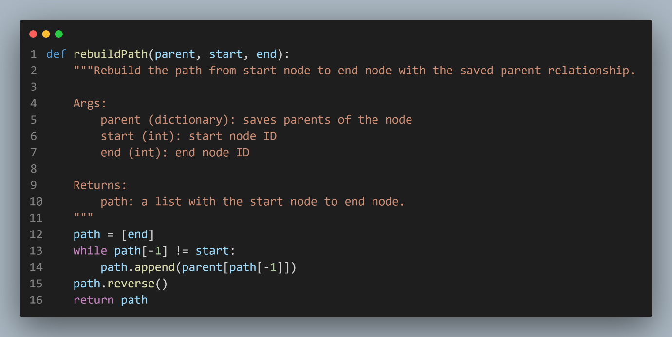

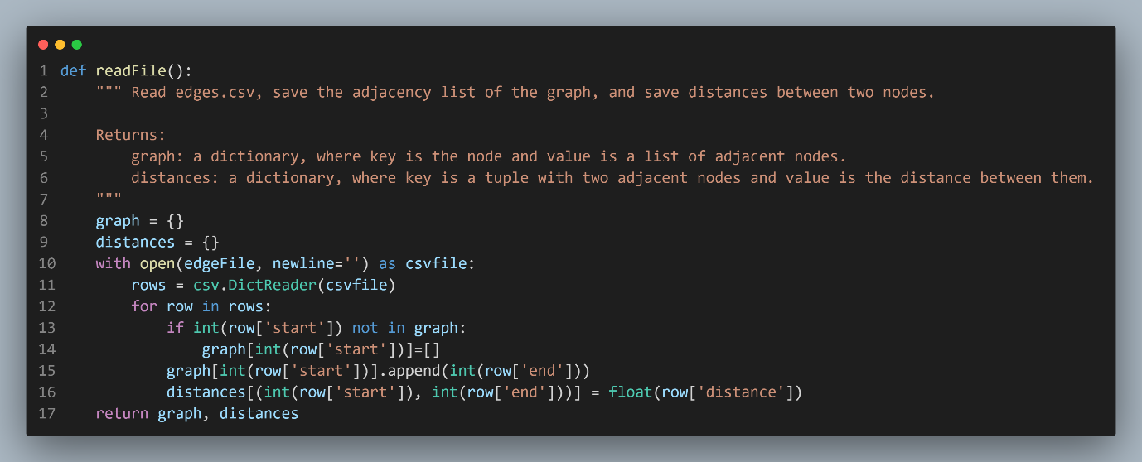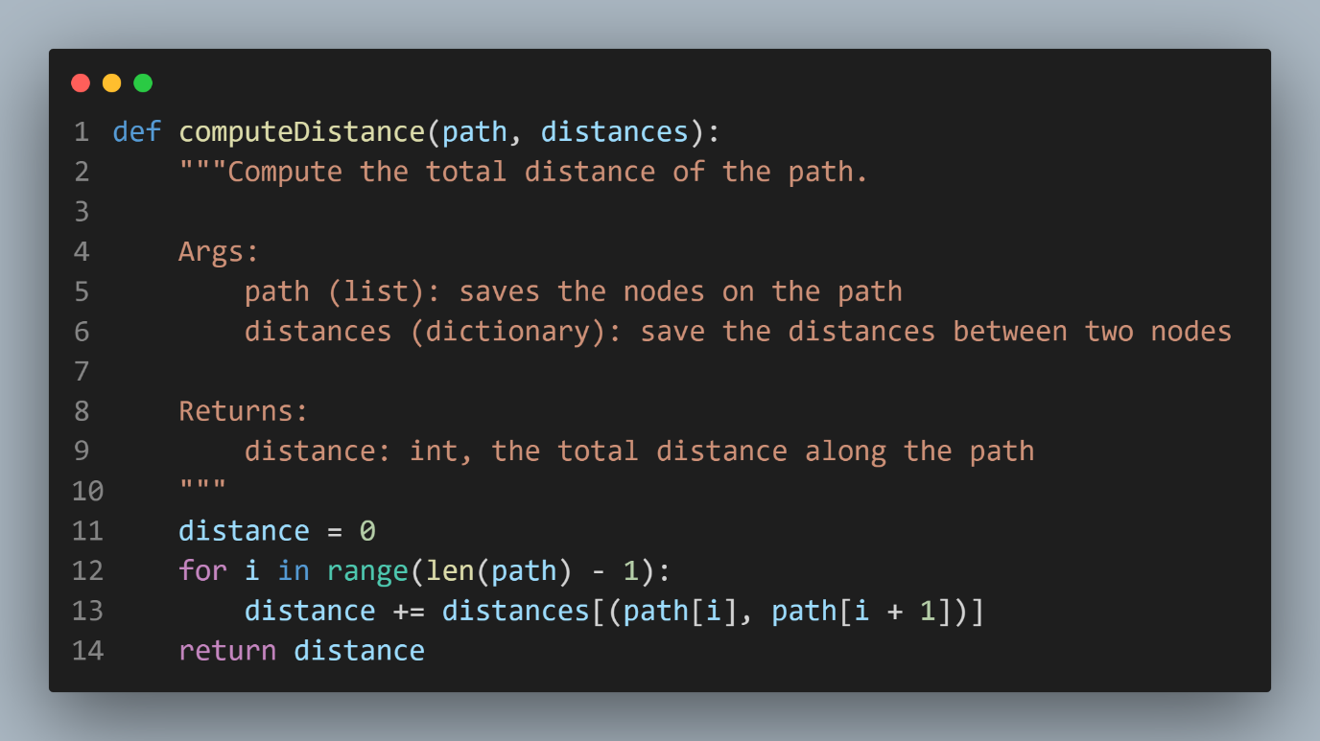

* **Part 2**

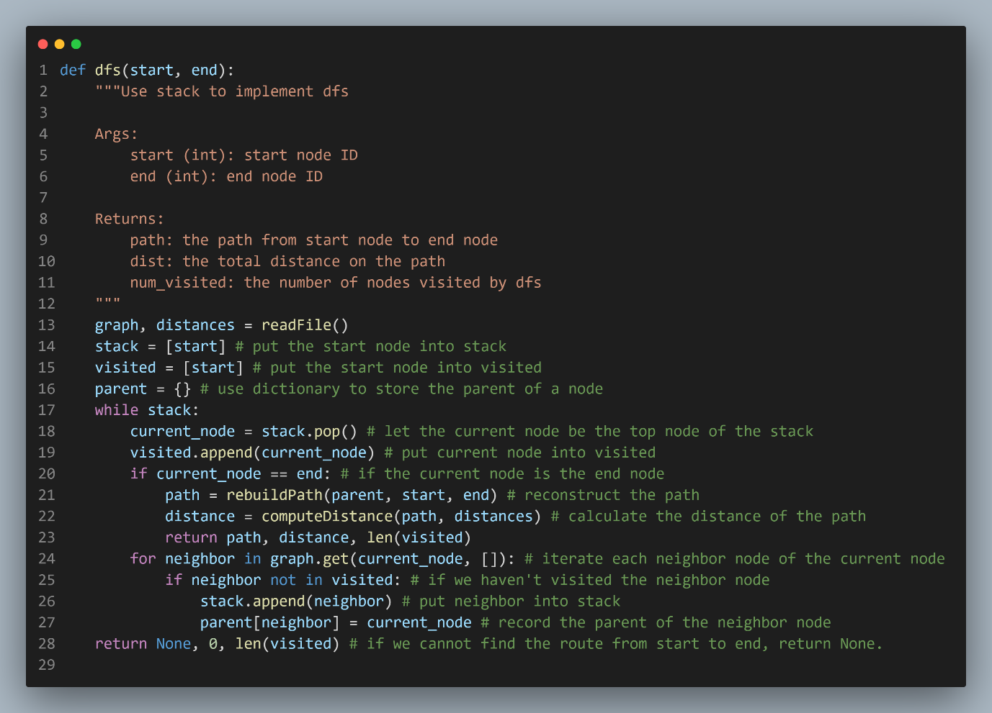

**The remaining function is the same as the bfs.py, so I wouldn’t paste it again.**

* **Part 3**

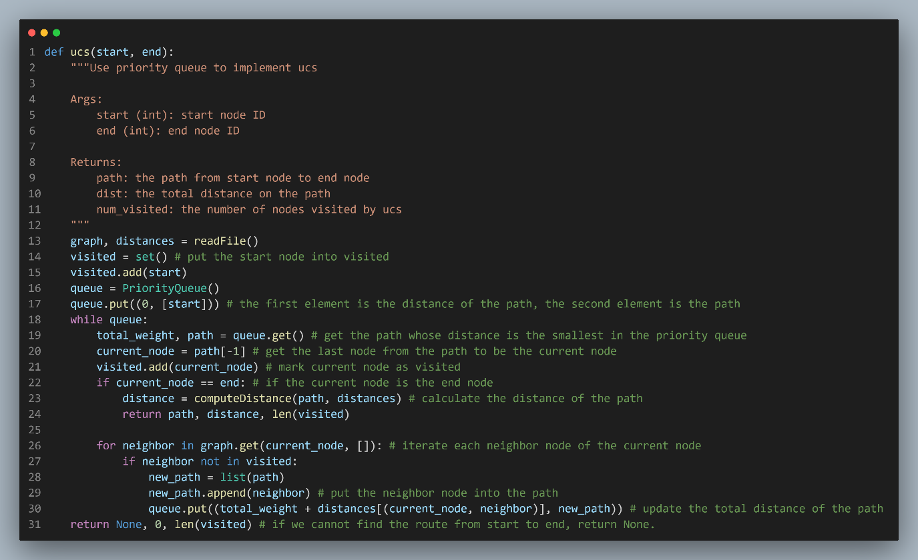

**The readFile function and computeDistance function are the same as the previous one, so I wouldn’t paste it again.**

* **Part 4**

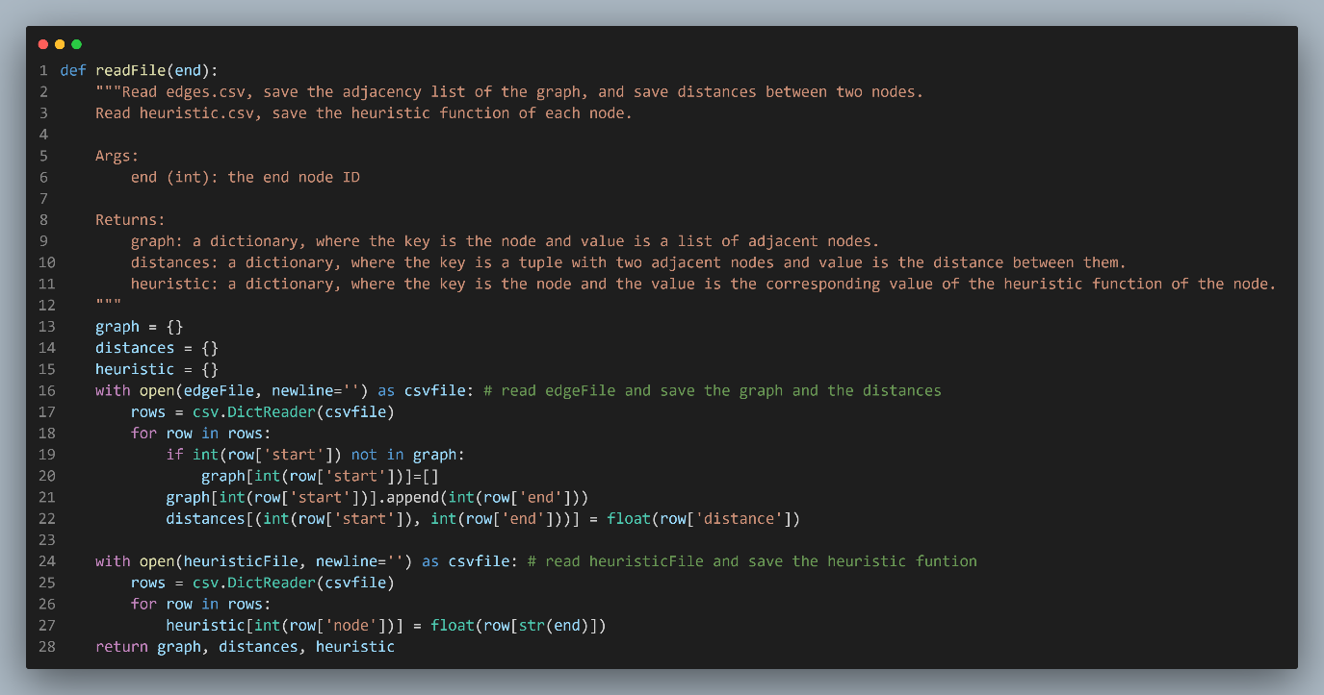

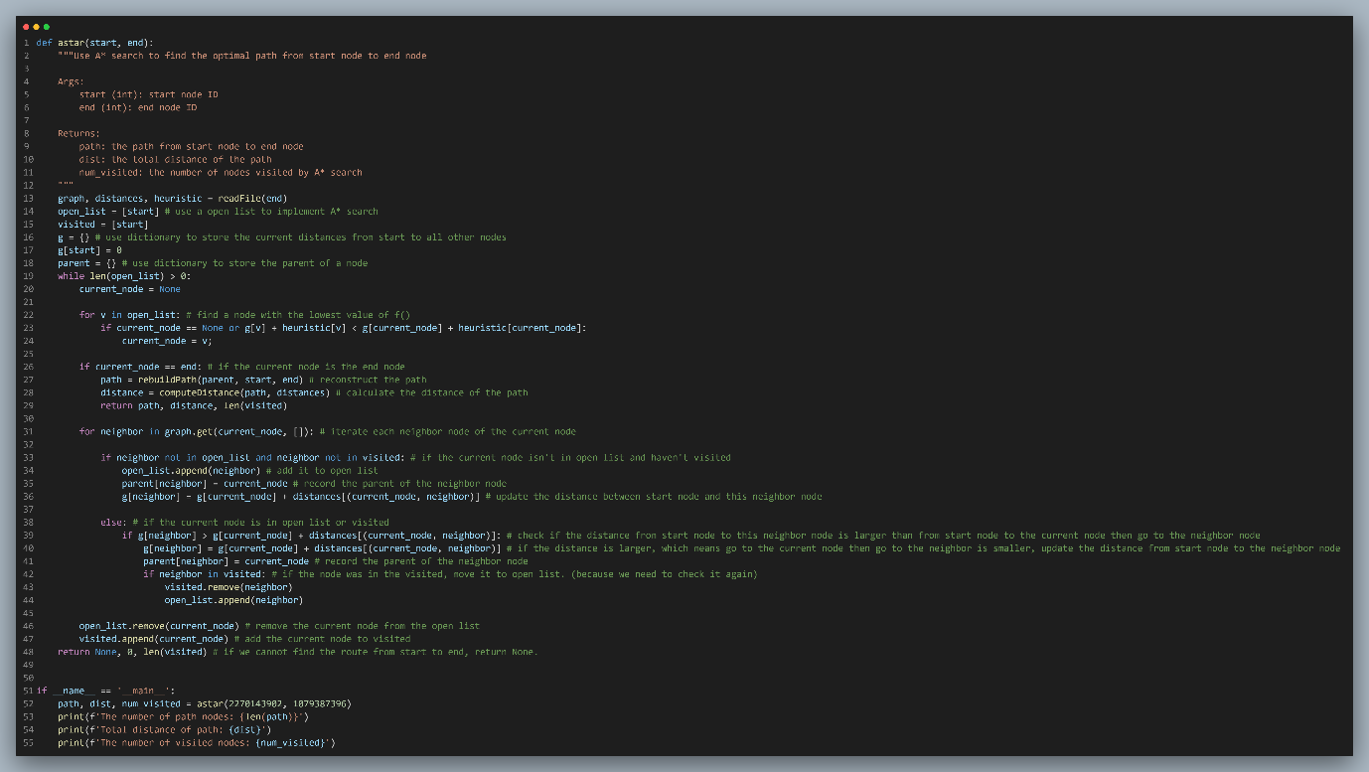

**The rebuildPath and the computeDistance function are the same as the previous one, so I wouldn’t paste it again.**

* **Part 6**

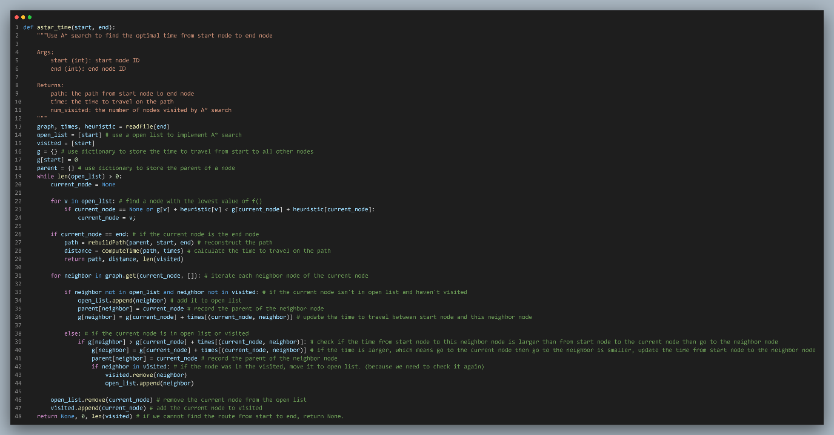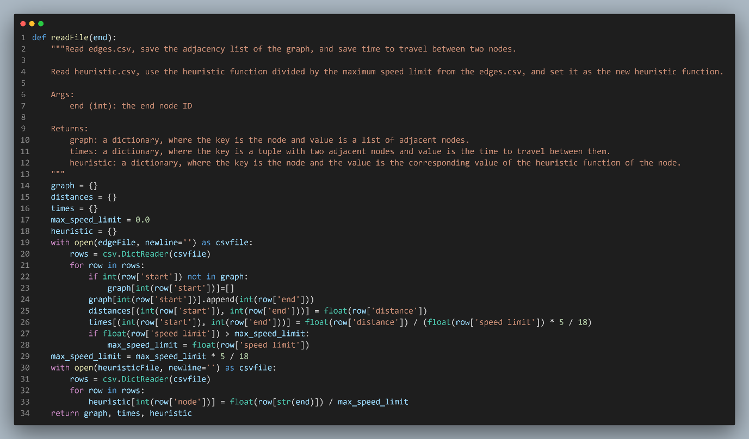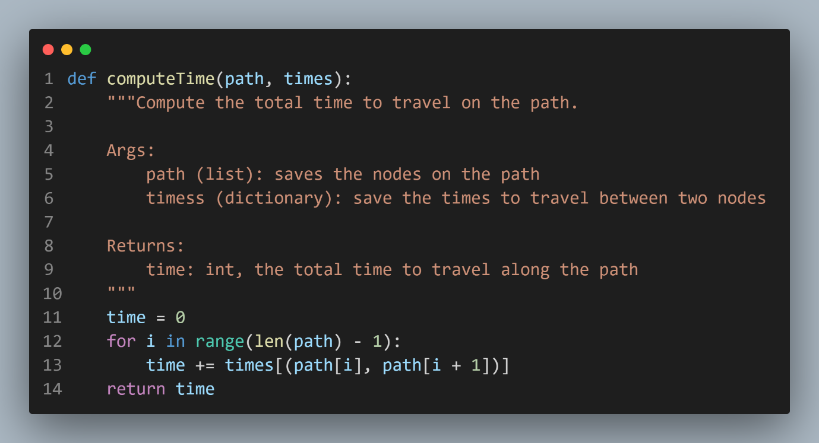

**The rebuildPath function is the same as the previous one, so I wouldn’t paste it again.**

**Part II. Results & Analysis (12%):**

* **Test 1：from National Yang Ming Chiao Tung University (ID: 2270143902) to Big City Shopping Mall (ID: 1079387396)**
  + BFS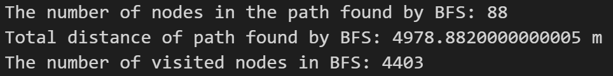 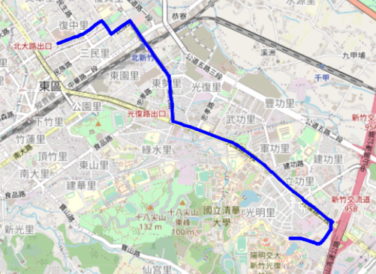
  + DFS (stack) 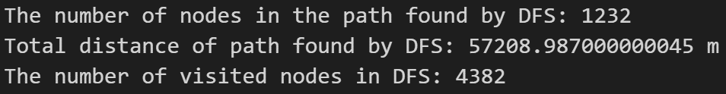 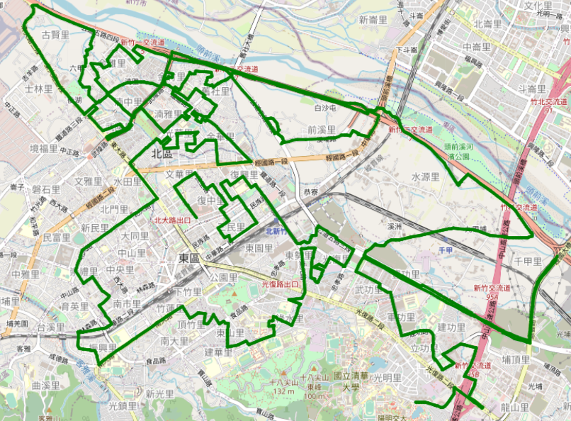
  + UCS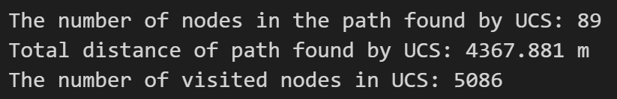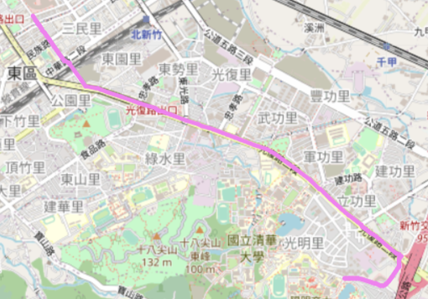
  + Astar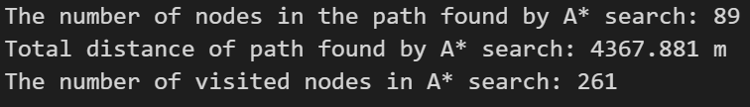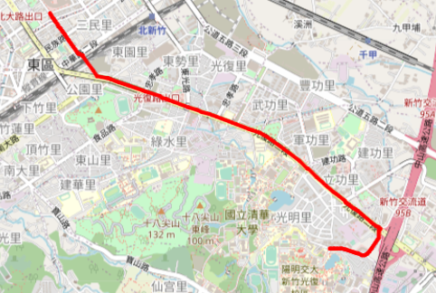
  + Astar_time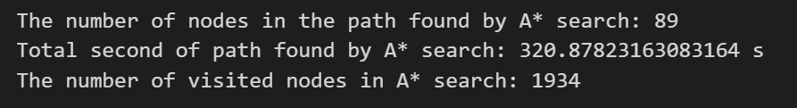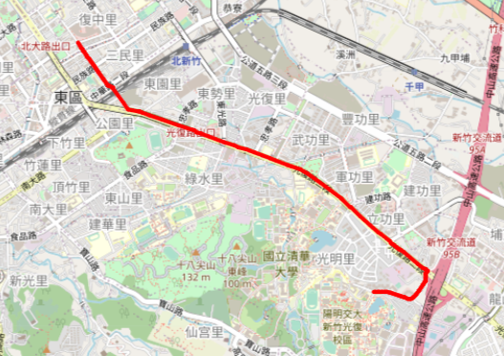
* **Test 2：from Hsinchu Zoo (ID: 426882161) to COSTCO Hsinchu Store (ID: 1737223506)**
  + BFS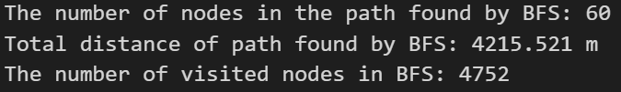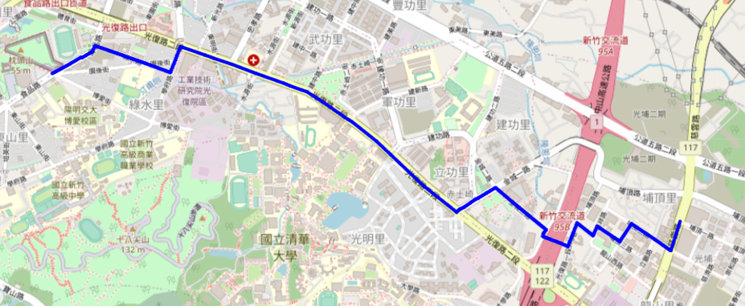
  + DFS (stack) 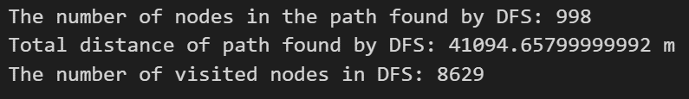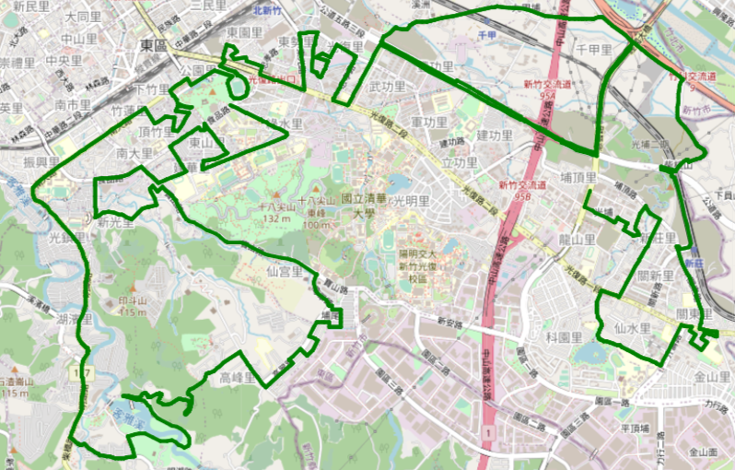
  + UCS

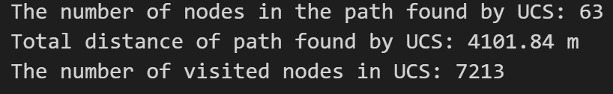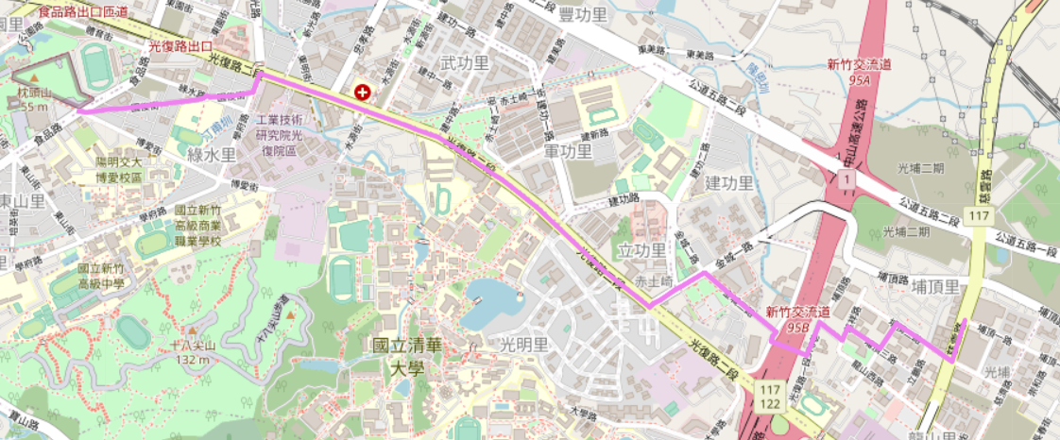

* + Astar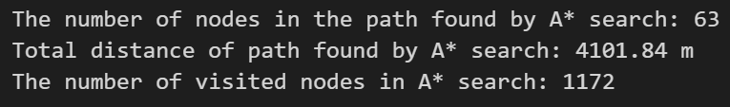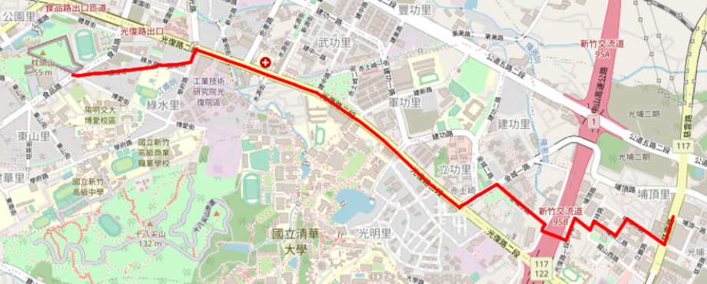
  + Astar_time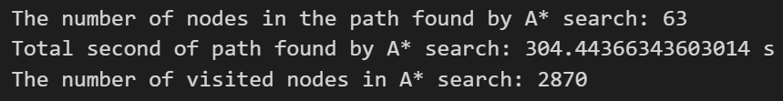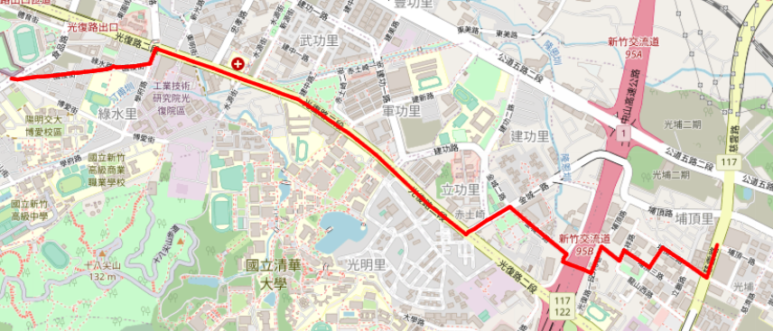
* **Test 3：from National Experimental High School At Hsinchu Science Park (ID: 1718165260)to Nanliao Fighing Port (ID: 8513026827)**
  + BFS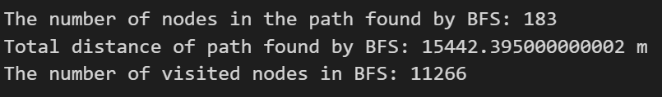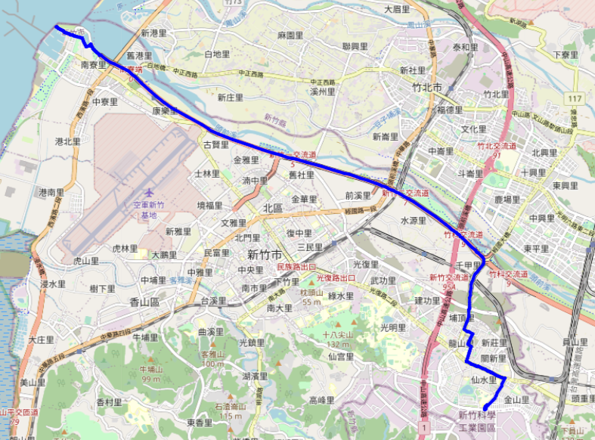
  + DFS (stack) 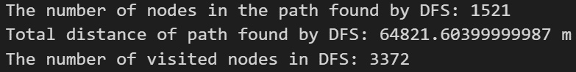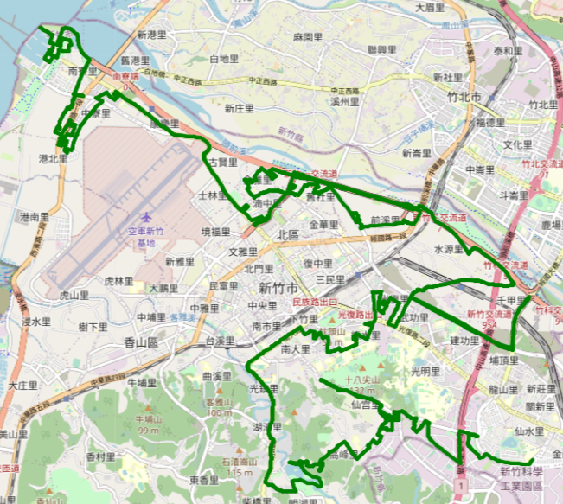
  + UCS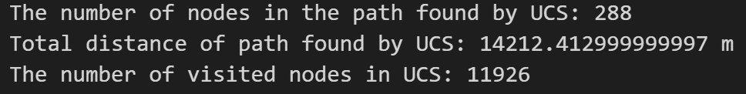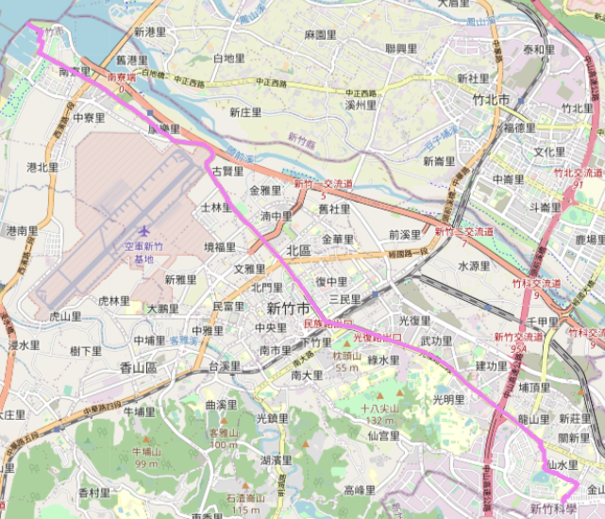
  + Astar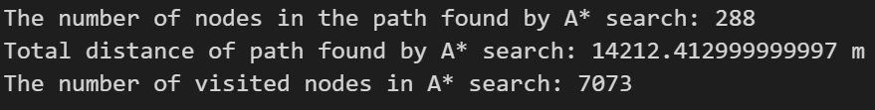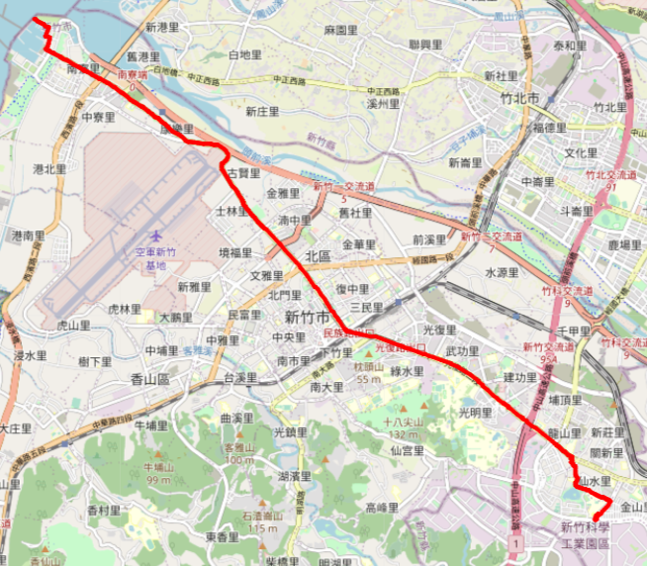
  + Astar_time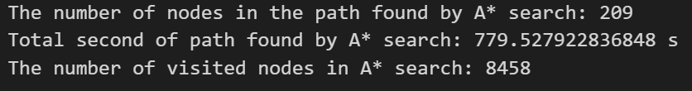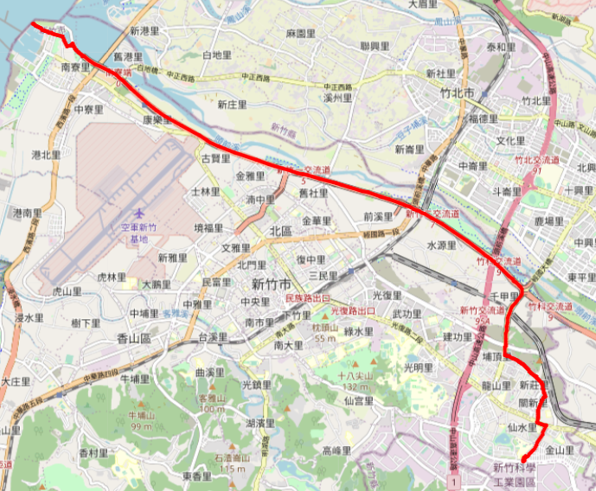
* Overall Analysis:
  + The average performance of each path finding algorithm:

Based on my testing of the path finding algorithms, the A* search and UCS algorithms have shown to have the best performance in terms of finding an optimal path. However, UCS requires iterating through more nodes than A* search.

On the other hand, BFS also performs reasonably well and is able to find a decent result with fewer node iterations than UCS.

In contrast, DFS typically produces longer paths than the other algorithms. However, the number of nodes iterated by DFS can vary depending on the way the adjacent list is stored. For instance, in test 1 and test 2, DFS iterated more nodes than BFS. However, in test 3, DFS only iterated 2494 nodes while BFS iterated 11266 nodes.

* + The design of heuristic function in part 6:

For the design of the heuristic function in part 6, I used the original heuristic function found in the heuristic.csv file and divided it by the maximum speed limit that can be found in the edge.csv file. This heuristic function is considered admissible because it follows the admissible heuristic principle that was discussed in class, as shown in the following image: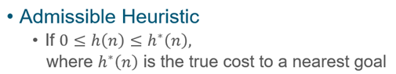

Since there are various speed limits on each edge, selecting the maximum speed limit implies that we can travel faster than the limit on some edges. As a result, the heuristic function I designed can ensure that it is always less than or equal to the true cost to the nearest goal, making it an admissible heuristic.

* + The comparison of Part 4 and Part 6:

In part 4, the number of visited nodes is typically lower than in part 6. Additionally, in test 1 and test 2, both algorithms discovered the same path. However, in test 3, the path found in part 4 differed from the path found in part 6. The reason for this difference is due to the varying speed limits on the edges.

The pathfinding algorithm used in part 4 does not consider speed limits, whereas the algorithm used in part 6 does. As a result, the path discovered in part 4 may not be optimal or even valid if the edges' speed limits affect the path's feasibility.

In contrast, the pathfinding algorithm used in part 6 accounts for speed limits when determining the optimal path, which results in a path that is both valid and optimal. As a consequence, the algorithm in part 6 may visit more nodes than the algorithm used in part 4 since it considers additional factors that impact the pathfinding process.

**Part III. Question Answering (12%):**

1. Please describe a problem you encountered and how you solved it.

While implementing the BFS algorithm, I encountered some difficulties with storing the edge information. In my initial attempt, I used a dictionary to store the edge information where the first node was the key, and the value was a tuple of the second node and the distance between them. However, accessing and implementing the BFS algorithm using this data structure was challenging.

After a few days, I came up with an alternative solution. I decided to store the adjacent edges and their distances separately. To my surprise, I discovered that a tuple could be used as the key for a dictionary, which simplified the process of accessing the distances between the adjacent nodes significantly.

By storing the adjacent edges and their distances separately and using tuples as the keys for the dictionary, I was able to access and implement the BFS algorithm with greater ease and efficiency.

1. Besides speed limit and distance, could you please come up with another attribute that is essential for route findingin the real world? Please explain the rationale.

Another attribute that is crucial for route finding in the real world is the traffic flow. Knowing the traffic flow of each road segment can help in determining the optimal route to take. High traffic flow can lead to congested roads, which would result in longer travel times and potentially impact the overall travel schedule.

By incorporating real-time traffic flow information into the route-finding algorithm, users can receive up-to-date information on the current traffic conditions, allowing them to adjust their route and avoid potential traffic delays. This can result in faster and more efficient travel times, as well as a more accurate representation of the expected travel time.

To sum up, incorporating traffic flow data into the route-finding algorithm can provide a more accurate and reliable navigation experience for users and help them make better-informed decisions when planning their travel routes.

1. As mentioned in the introduction, a navigation system involves mapping, localization, and route finding. Please suggest possible solutions for **mapping** and **localization** components?
   * For the mapping component, one possible solution is to use satellite imagery or aerial photography to create high-resolution maps. These maps can be generated using computer vision techniques, such as image segmentation and object detection, to identify and label different features, such as roads, buildings, and landmarks. The maps can also be updated in real-time using crowdsourcing or sensor data from vehicles or drones.
   * For the localization component, one possible solution is to use GPS or other positioning technologies, such as Bluetooth beacons or Wi-Fi triangulation, to determine the location of the user or vehicle. However, GPS signals can be affected by interference or obstacles, such as tall buildings or tunnels, which can result in inaccurate or unreliable location estimates.
2. The estimated time of arrival (ETA) is one of the features of Uber Eats. To provide accurate estimates for users, Uber Eats needs to dynamically update ETA based on their mechanism. Please define a **dynamic heuristic** **equation** for ETA and explain the rationale of your design. Hint: You can consider meal prep time, delivery priority, multiple orders, etc.

A dynamic heuristic equation for ETA in Uber Eats can be defined as follows:

1. If there is no order on the nearest deliver,

**ETA = Meal preparation time + (Time to travel from the location of nearest deliver to restaurant) + (Time to travel from restaurant to customer)**

2. If there is one or more order on the nearest deliver and the priority of this new order is higher than the previous one,

**ETA = Meal preparation time + (Time to travel from the location of nearest deliver to restaurant) + (Time to travel from restaurant to customer who is the highest priority) + The average interacting time between delivers and customers + (Time to travel from customer who is the highest priority to the second priority) + The average interacting time between delivers and customers + … + (Time to travel from the previous customer to the customer who ordered this order)**

Noted that we don’t need to consider the previous meal with lower priority in this case, because VIP is always the best 😊.

* The logic flow I think a general deliver will do is:

1. Turn on the App and check the nearest order and the destination

2. Click accept the order and go to the restaurant

3. While waiting the meal, check whether there is an order that will have a short distance between the deliver and the restaurant, and a short distance between two destinations. If so, click accept.

4. Deliver the meal to the customer.

I must admit that this is a relatively easy logic flow. In the real world, the nearest deliver may not to accept the meal due to the time and the money. Or the deliver may not accept another order while waiting the meal due to some reasons. This is just my logic flow, don’t dig in too much.

* When the nearest deliver has no orders, we can easily define the ETA.
  + Meal preparation time: The amount of time it takes for the restaurant to prepare the order. This factor can vary depending on the type of cuisine, the complexity of the order, and the restaurant's current workload.
  + Time to travel from the location of nearest deliver to restaurant: If we need to implement this, there are too many attributes we need to take into consideration. For example, the traffic light waiting time and the current traffic flow on each road. I think when Uber needs to implement this, they can simply get a google map API to know the possible travel time of the deliver to the restaurant.
  + Time to travel from restaurant to customer: This is the same problem as “Time to travel from the location of nearest deliver to restaurant”.
* However, if there are one or more orders on the deliver, I think we need to take the priority of each customer. For example, Uber VIP may have the highest priority, the normal user have the second high priority, and the user who may ordered the meal and didn’t pay for it may have the lowest priority. I assume that the priority had been decided in the Uber’s App.
  + Meal preparation time + (Time to travel from the location of nearest deliver to restaurant): This is like the previous one.
  + Time to travel from restaurant to customer who is the highest priority: This is the same problem as the previous “Time to travel from restaurant to customer”.
  + The average interacting time between delivers and customers: Because there are multiple order between customers, I think Uber may have the average interacting time between delivers and customers in their database, so we need to take it into consideration.
  + (Time to travel from customer who is the highest priority to the second priority) + The average interacting time between delivers and customers + … + (Time to travel from the previous customer to the customer who ordered this order): This is like combining previous two problems. Noted that if the priority of two meals is the same, pick the closer one to the deliver.
* Noted that meal preparation time may overlap with the time to travel from the location of nearest deliver to restaurant. In my opinion, the value of admissible heuristic must be smaller than the true cost to the nearest goal, so it is tolerable.